Module 1 – Introduction to Data Visualization and The Power of Tableau
1.1 What is Data Visualization?
Data Visualization is the process of presenting data in a graphical or visual format such as:
- Charts
- Graphs
- Maps
- Dashboards
- Tables
It helps people understand:
- Trends
- Patterns
- Comparisons
- Relationships
- Business insights
Instead of reading thousands of rows in Excel, visualization makes information easy to understand quickly.

Why Data Visualization is Important
Example (Raw Data)
Month | Sales
Jan | 45000
Feb | 52000
Mar | 61000
Apr | 70000
Reading numbers takes time.
Example (Chart View)
A line chart instantly shows:
- Sales are increasing month by month
- Growth trend is positive
This is the power of visualization.

1.2 Comparison and Benefits Against Reading Raw Numbers
Raw Numbers vs Visualization
Raw Numbers | Visualization
Difficult to analyze | Easy to understand
Time consuming | Quick decision making
Hard to identify trends | Trends visible instantly
Not attractive | Interactive and visually appealing
Difficult for management reporting | Best for presentations and dashboards

Benefits of Data Visualization
1. Easy Understanding
Complex data becomes simple.
2. Faster Decision Making
Managers can quickly identify issues and opportunities.
3. Trend Analysis
Find increase/decrease patterns easily.
4. Better Business Insights
Helps companies improve sales, profit, and customer satisfaction.
5. Interactive Reporting
Users can filter and drill down data.

1.3 Real Use Cases from Various Business Domains
1. Sales Domain
Use Case:
Track:
- Monthly sales
- Region-wise sales
- Top products
- Sales growth
Visualization Used:
- Bar Chart
- Line Chart
- Dashboard

2. HR Domain
Use Case:
Analyze:
- Employee attendance
- Attrition rate (employees who leave a company)
- Department performance
Visualization Used:
- Pie Chart
- Heat Map
- KPI Cards (KPI- Key Performance Indicator)

3. Banking Domain
Use Case:
Monitor:
- Loan approvals
- Fraud detection
- Customer transactions
Visualization Used:
- Dashboards
- Scatter plots
- Trend charts

4. Healthcare Domain
Use Case:
Track:
- Patient records
- Disease spread
- Hospital performance
Visualization Used:
- Geographic maps
- Line charts
- KPI dashboards

5. E-Commerce Domain
Use Case:
Analyze:
- Customer purchases
- Product performance
- Delivery tracking
Visualization Used:
- Funnel charts
- Sales dashboards
- Maps

1.4 Quick and Powerful Examples Using Tableau
Example 1 – Sales Dashboard
Using Tableau, you can create:
- Total Sales KPI
- Region-wise sales map
- Monthly sales trend
- Top 10 products
Within minutes using drag-and-drop features.

Example 2 – COVID-19 Dashboard
Tableau can visualize:
- Country-wise cases
- Recovery rates
- Death percentages
- Daily trend analysis
Interactive dashboards help governments and hospitals.

Example 3 – Student Performance Dashboard
Analyze:
- Student marks
- Attendance
- Subject performance
Teachers can identify weak students quickly.

Features of Tableau
Tableau is Popular Because:
- Easy drag-and-drop interface
- No heavy coding required
- Fast dashboard creation
- Interactive visualizations
- Connects with multiple data sources
- Real-time analysis

1.5 Installing Tableau
Tableau Products
1. Tableau Desktop
Used for:
- Creating reports
- Dashboards
- Data analysis
2. Tableau Public
Free version used for learning.

Steps to Install Tableau Public
Step 1:
Visit Tableau official website.
Step 2:
Download Tableau Public.
Step 3:
Run setup file.
Step 4:
Click:
- Next
- Install
- Finish
Step 5:
Open Tableau Public.

Minimum System Requirements
Requirement | Details
OS | Windows 10/11
RAM | Minimum 4 GB
Processor | Intel i3 or above
Storage | 2 GB free space

1.6 Tableau Interface
Main Components of Tableau Interface
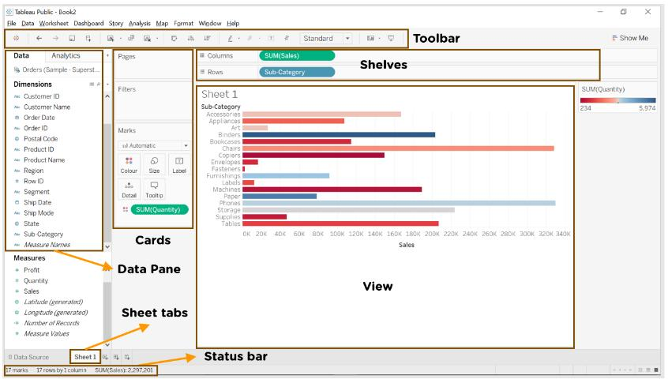
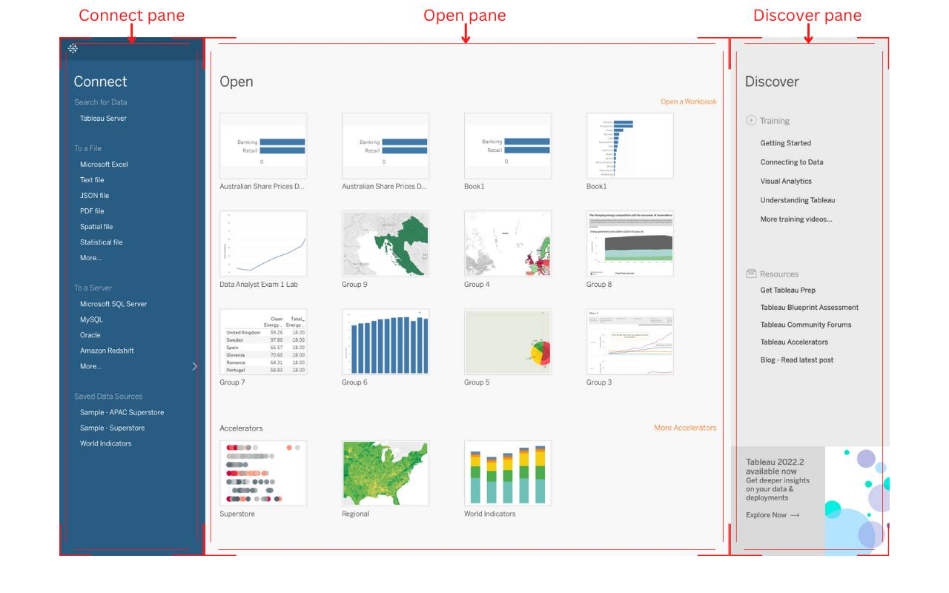
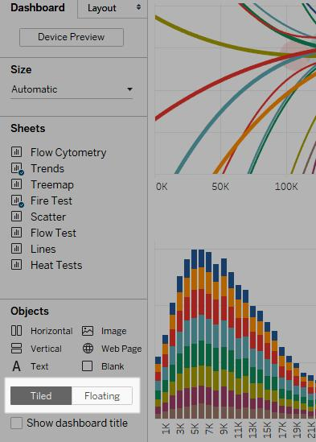

1. Menu Bar
Located at the top.
Used for:
- Save
- Open
- Export
- Connect data

2. Toolbar
Contains shortcut buttons:
- Undo
- Redo
- Save
- Sort
- Filters

3. Data Pane
Located on the left side.
Contains:
- Dimensions
- Measures
- Tables
- Fields
Example:
Dimensions | Measures
Region | Sales
Product | Profit

4. Shelves
Used to build charts.
Important Shelves:
- Columns
- Rows
- Filters
- Marks

5. Worksheet Area
Main working area where charts are created.

6. Marks Card
Controls:
- Color
- Size
- Label
- Tooltip
- Shape

Example – Creating a Simple Bar Chart
Step 1:
Connect Excel data.
Step 2:
Drag:
- Category → Columns
- Sales → Rows
Step 3:
Tableau automatically creates Bar Chart.

Types of Charts Available in Tableau
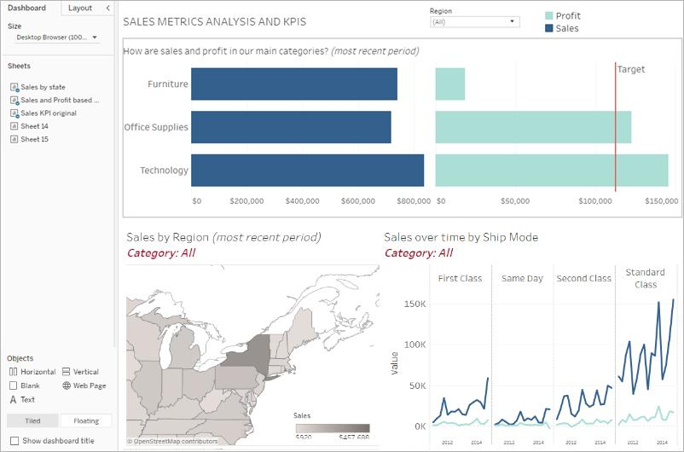
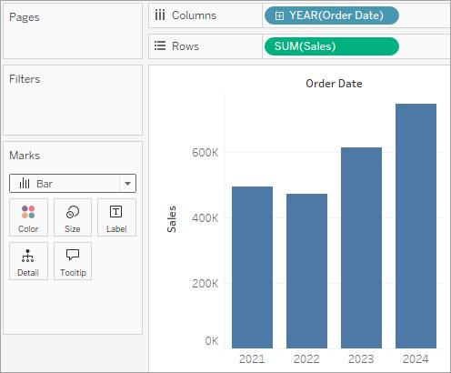
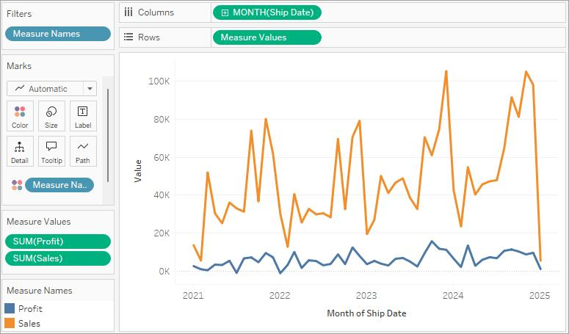

- Bar Chart
- Line Chart
- Pie Chart
- Scatter Plot
- Tree Map
- Heat Map
- Geographic Map
- Dashboard

Summary
In this module you learned:
- Introduction to Data Visualization
- Benefits of visualization over raw data
- Business use cases
- Introduction to Tableau
- Tableau installation
- Tableau interface basics
Tableau helps organizations convert raw data into meaningful business insights using interactive dashboards and visual analytics.

